In Visitar app, following are the credentials used

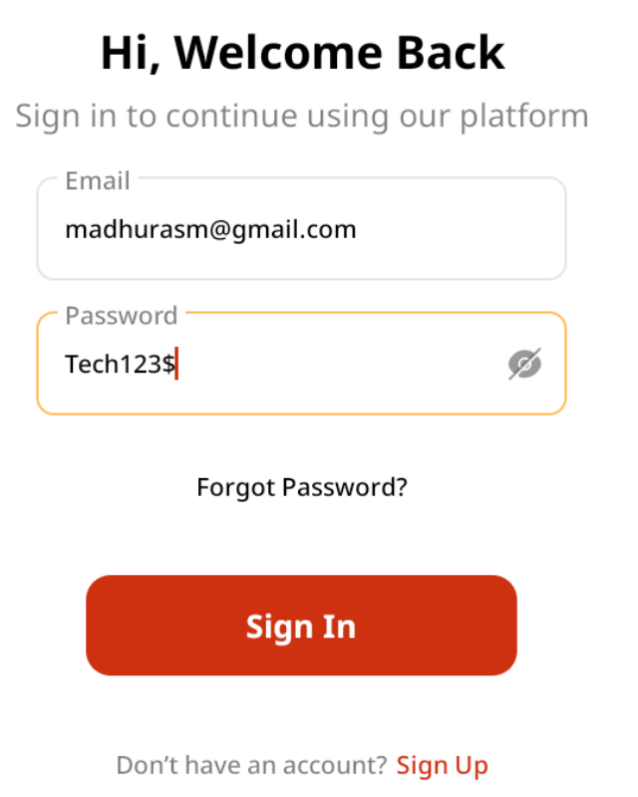

After logging in, select the Site name

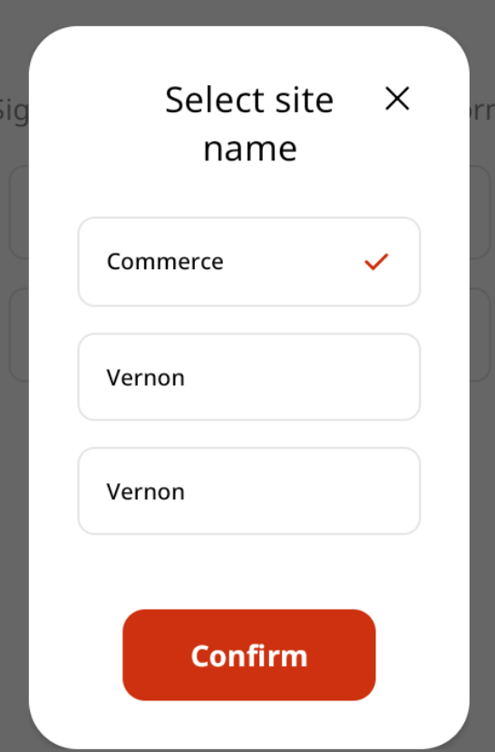

Receptionist is logged in. Click on Start Visitor Check-In to start the visitor check-in process,

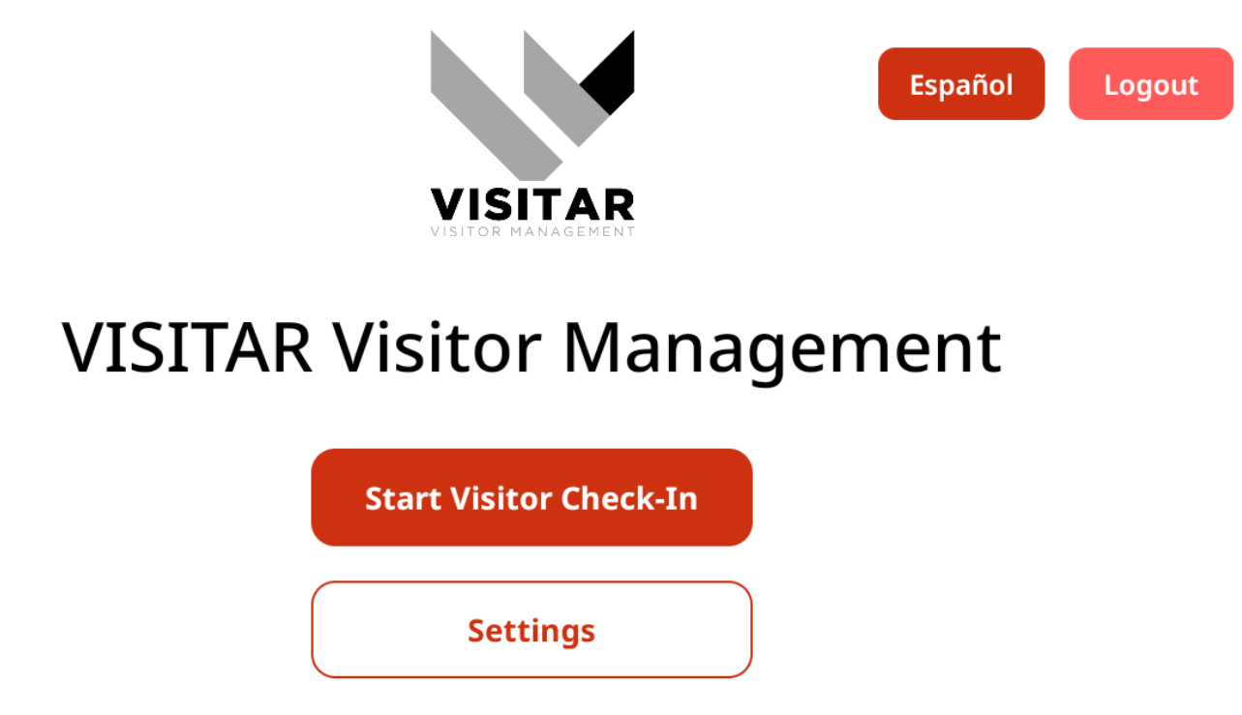

And the following screen is displayed

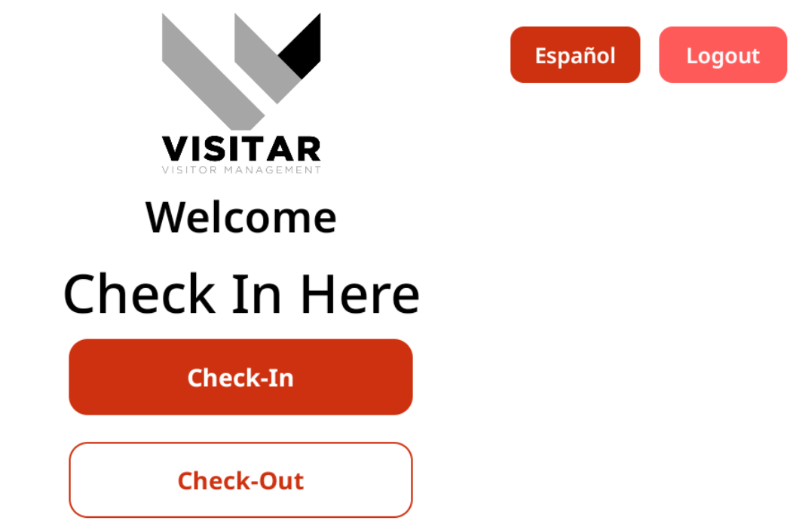

Clicking on the Check-In button, displays the Visitor Information screen where visitor enters his info.

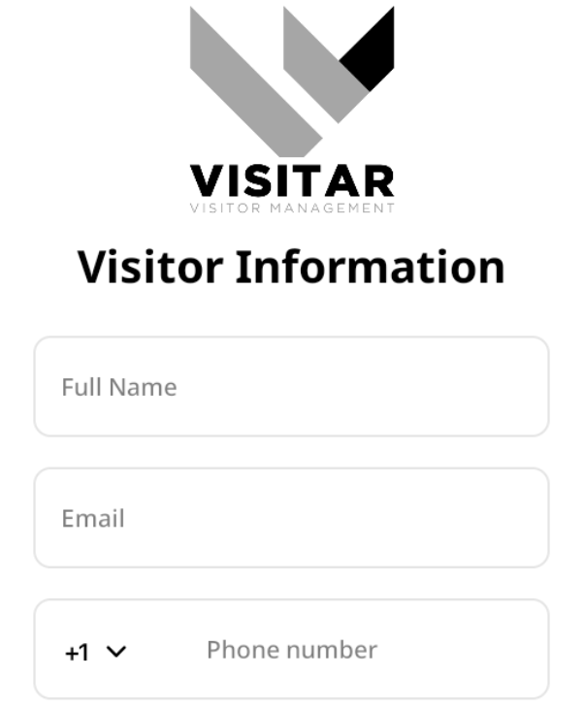

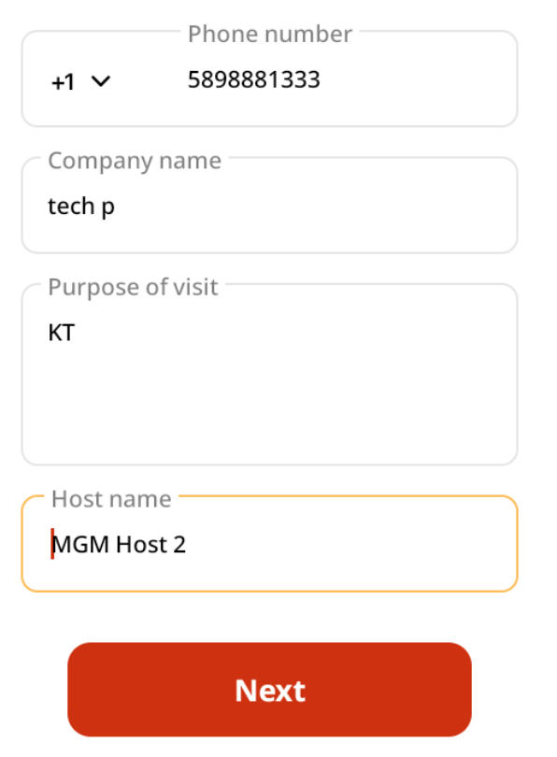

After the Next button is clicked, Waiver Policy screen appears and clicking on the Agree button

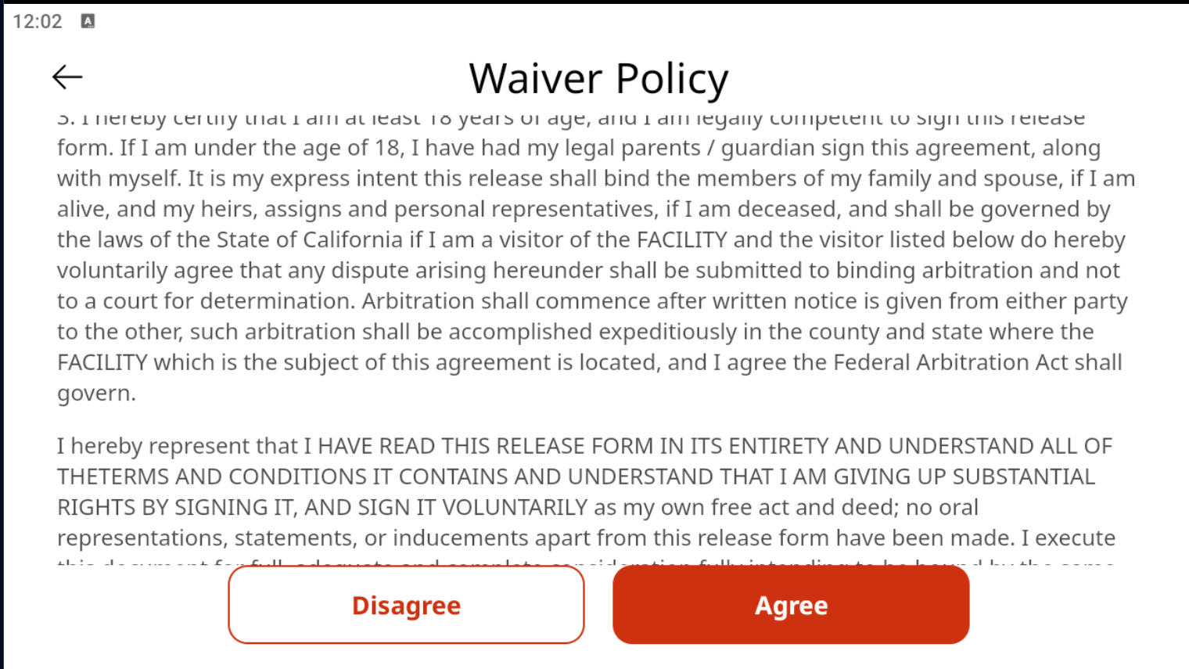

Takes to the next screen where the visitor’s photo is captured.



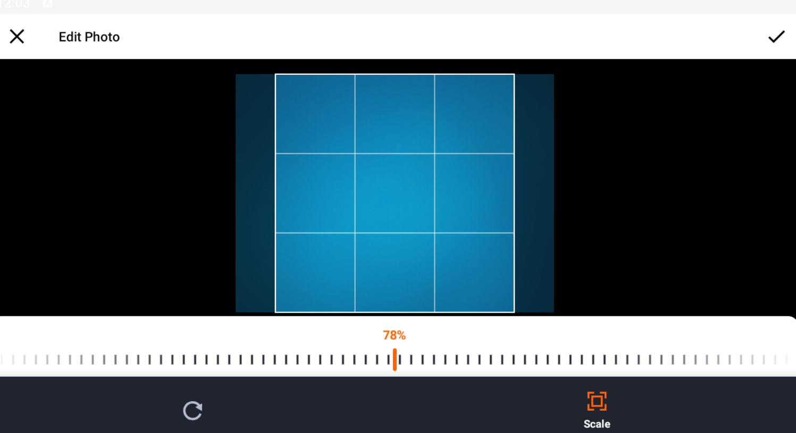

The Tick mark is clicked.

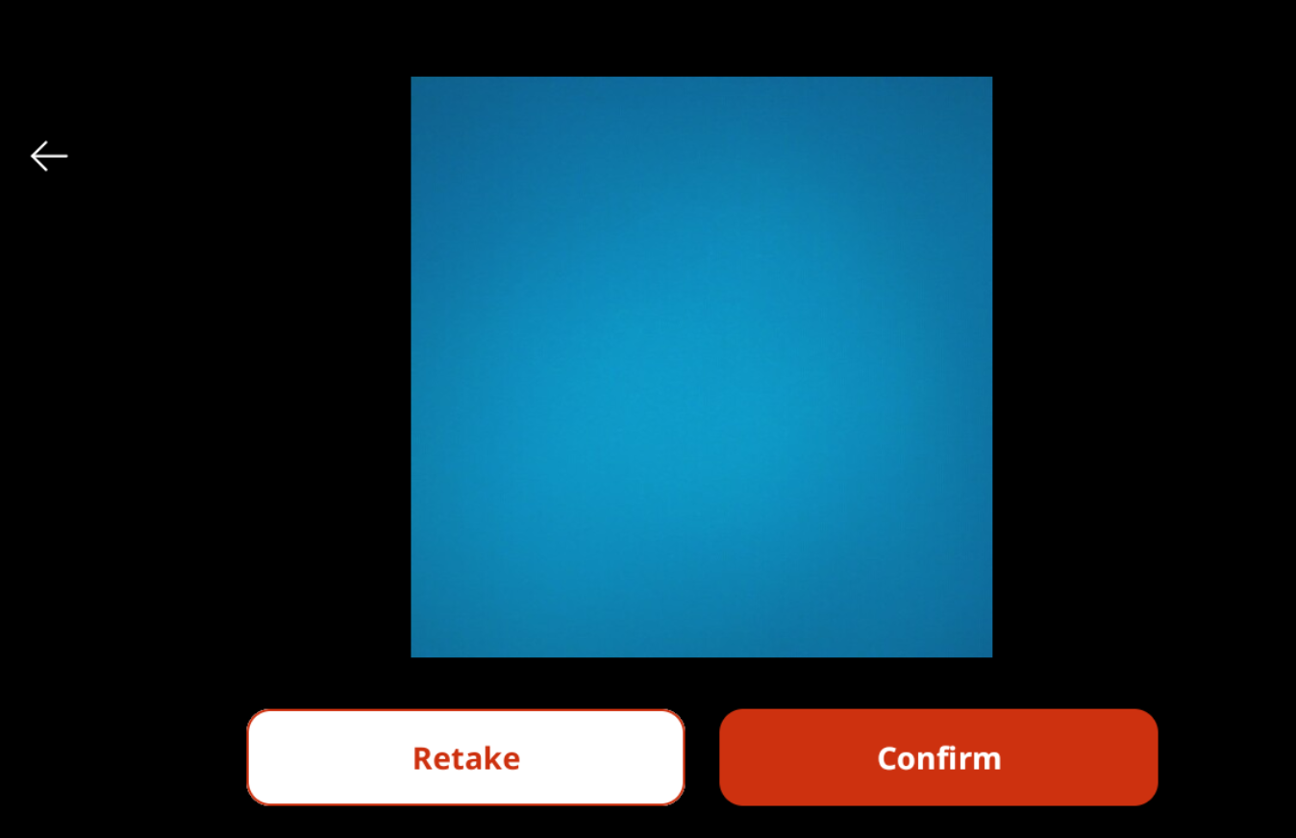

Click Confirm button and the Details screen is displayed as below:

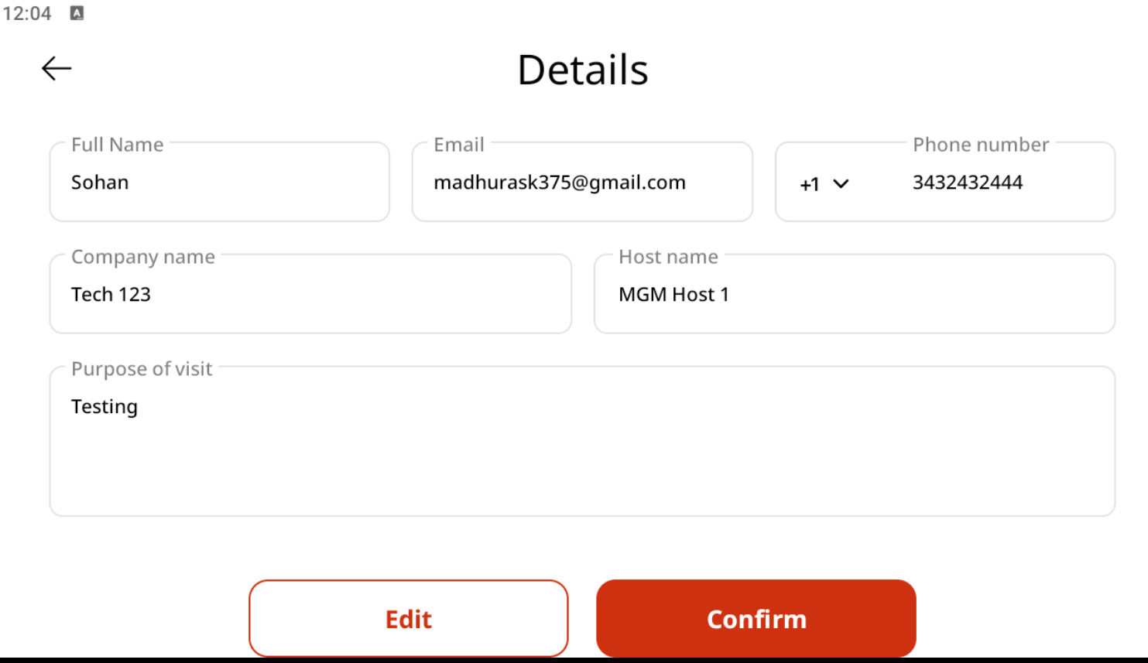

Clicking on Confirm button displays the following error on Visitar app. However, the host does receive the Visitor notification email where he can Accept or Reject.

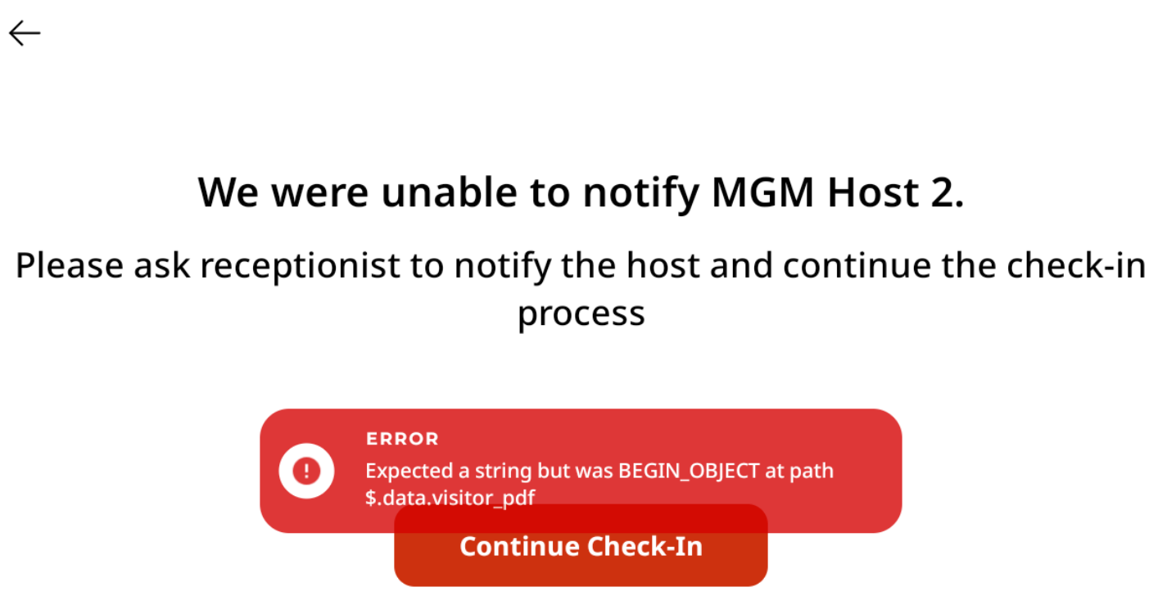

**NOTE**: Since the Host Name MGM Host 2 was selected when Visitor info was entered and MGM Host 2’s email access is not there, I was not able to take the screen shot.

But have verified it with other email and I did receive the Visitor notification email and its screenshot is as below:

